Steps to Create a Amazon RDS DB instance
Follow these steps to create an RDS DB instance using the AWS Management Console.
Step 1: Access the RDS Dashboard
- Log in to your AWS Management Console.
- Navigate to the Amazon RDS dashboard.
- Click on Create Database to start the setup process.
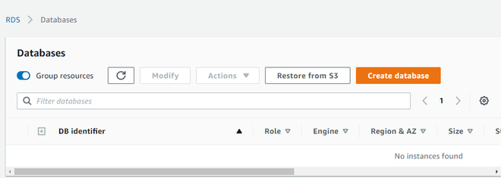
Step 2: Select a Database Engine
- Choose the Standard database creation method.
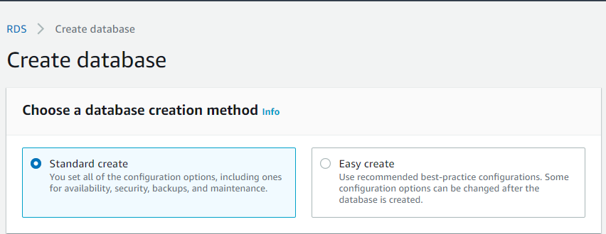Creation Method
- Select the MySQL database engine (or any other engine based on your requirements).
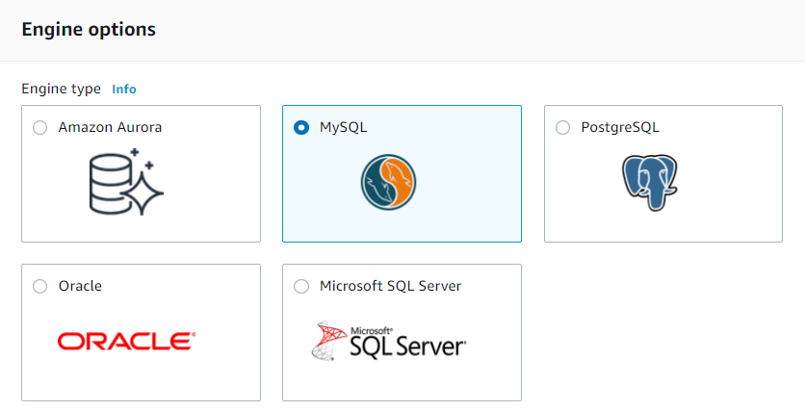
- Select the version of the MySQL that you want to use.
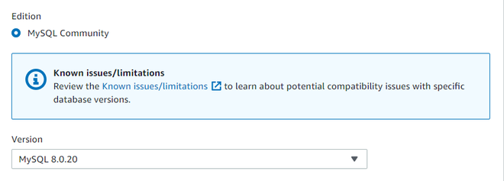Version of DB Engine
Step 3: Choose a Deployment Option
Under the Templates section, AWS offers three deployment options:
- Production – Suitable for high-performance applications.
- Dev/Test – Ideal for development and testing environments.
- Free Tier – Best for beginners and small-scale projects.
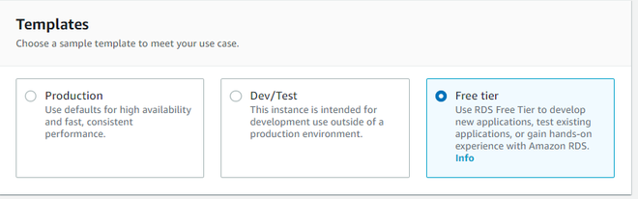Template Types
We will opt for Free tier.
Step 4: Configure Database Settings
- Set the DB instance identifier (e.g., geeksDemo).
- Enter a Master username (e.g., admin).
- Choose a strong password for database access.
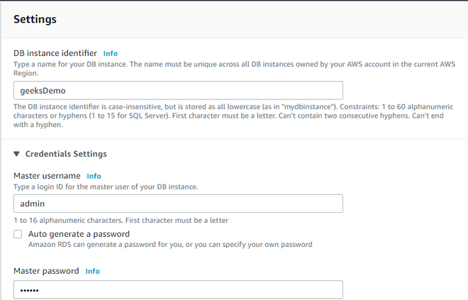Settings
Step 5: Select an Instance Type
- The db.t2.micro instance type is automatically selected under the Free Tier.
- If needed, choose an instance that fits your workload.
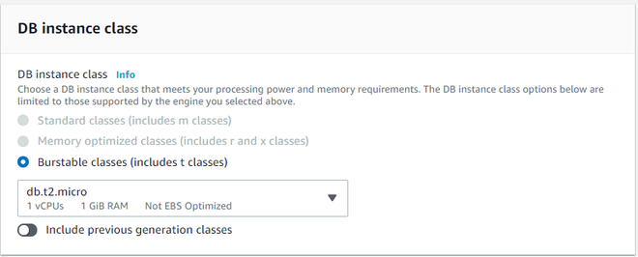DB Instance
Step 6: Finalize and Create the Database
- Click Create Database to launch the instance.
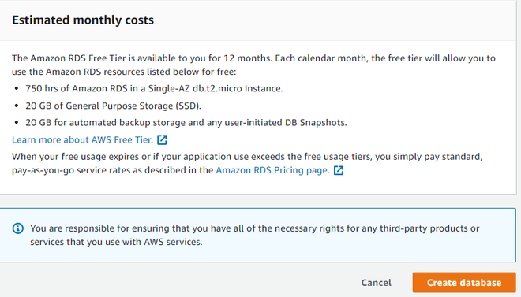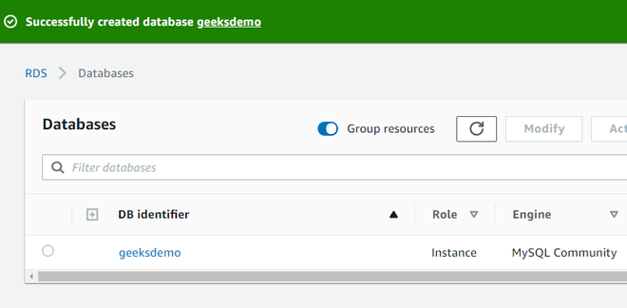
In the above image, we see that a MySQL database named geeksdemo has been created.

